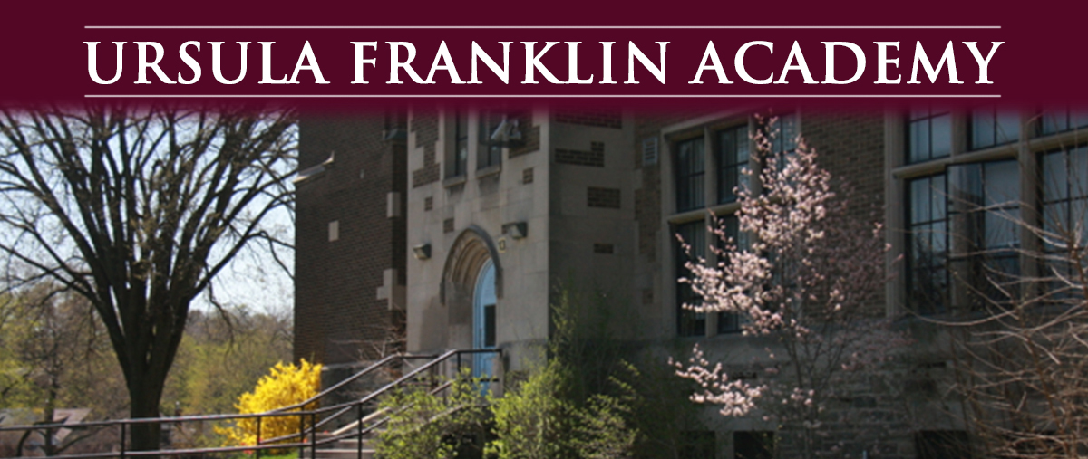
SAC Meeting
7:00 pm Tuesday, March 21st, 2023
in the UFA library
Everyone is welcome to attend.
- Welcome
- Report of Student Reports
- Report of Teacher /Staff
- Report of Principal - Petal Farquharson
- Ward Rep
- PAO group
Please email your questions and/or concerns by the Monday prior to the meeting: ufa.sac@gmail.com
_________________________________________________________________________________
If this e-mail was forwarded to you and you would like to sign-up to receive it please visit: https://mailchi.mp/41410d8c170f/ufa-school-advisory-council-newsletter-sign-up

We welcome all opinions and questions, but please remember that all communications should be done respectfully.
For further info contact ufa.sac@gmail.com

