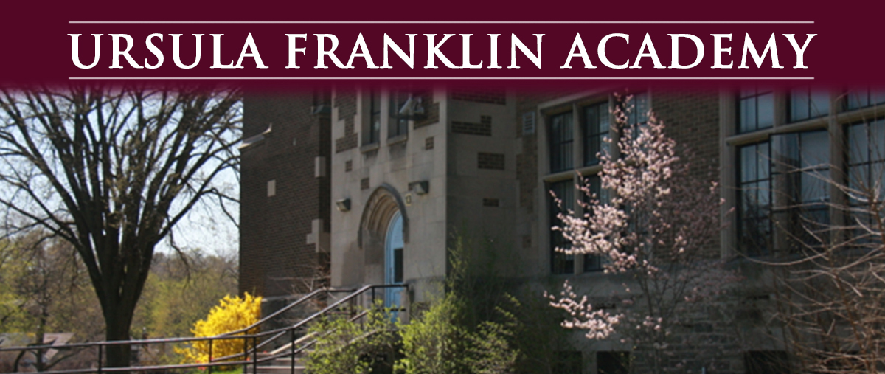
SAC Meeting 8:00 pm
Tuesday, January 24th, 2023 in the UFA library
Tuesday, January 24 at 7 p.m. in the UFA library will be the Course Selection Information Night for Parents. All Grade 9 – 11 parents are strongly encouraged to attend. The School Council meeting will follow at 8 pm.
The UFA SAC and UFA Anti-Oppression Parent and Caregiver Group are organizing a THANK YOU LUNCH for our wonderful 40 teachers and staff at UFA on Wednesday February 8th.
Sign up Here
Everyone is welcome to attend.
- Welcome
- Report of Student Reports
- Report of Teacher /Staff
- Report of Principal - Petal Farquharson
- PAO group
Please email your questions and/or concerns by the Monday prior to the meeting: ufa.sac@gmail.com
_________________________________________________________________________________
If this e-mail was forwarded to you and you would like to sign-up to receive it please visit: https://mailchi.mp/41410d8c170f/ufa-school-advisory-council-newsletter-sign-up
We welcome all opinions and questions, but please remember that all communications should be done respectfully.
For further info contact ufa.sac@gmail.com

